Lecture 8 (Nov 2, 2020)

Assignment 8

No quiz this weekend

1. Tips dataset (tip is not included in total price)
2. Naïve Bayesian using sklearn
3. Shapley feature Extraction

Nov 9, 16, 23, 30

Project Presentations: Dec 7

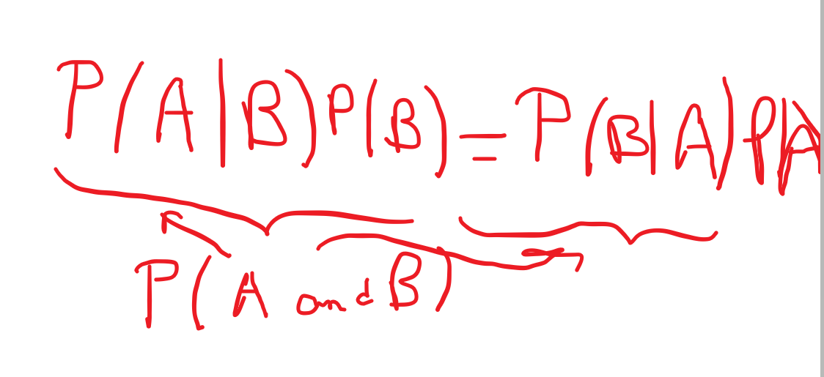

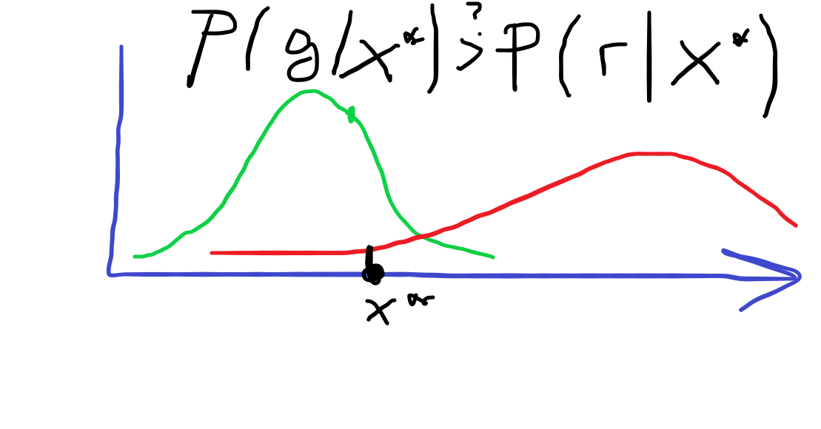

assign label that gives higher conditional probability

